# **ZonBase Review**

A new market for both customers and sellers has been developed due to the growth of e-commerce. With over 1 million active suppliers on its platform, Amazon is a significant participant in this market thanks to its extensive global reach.

There is no better method to learn how to sell things online through the Amazon marketplace than to read evaluations of specific software packages like [Zonbase](https://www.zonbase.com/). ZonBase is a product analysis program created to assist businesses in learning more about the items in Amazon's database.

Products research, keyword research, and listing optimization tools are all part of the ZonBase package. You can construct automated campaigns using efficient technologies, so PPC Automation won't be left behind.

Every all-encompassing software should include these fundamental tools. Although you have access to a sales estimator, photo enhancer, and earnings tool with ZonBase, it doesn't provide basic service.

# What is ZonBase?

Zonbase is a web-based cloud platform that contains 13 tools to assist Amazon merchants with three essential activities. These are all-in-one services, including product research, sales optimization, and listing optimization for the items on the website. Administrators may track sales using the platform's estimator tool, which tracks Amazon Standard Identification Numbers (ASINs).

Teams may also validate items in compliance with Fulfillment by Amazon (FBA) standards and examine the market competition using ZonBase. ZonBase provides stakeholders with a consistent interface via which they may improve product listings and track product ranking depending on particular keywords.

ZonBase makes introducing the items simple, finding out what's selling, and getting sales intelligence. Having a complete collection of tools will benefit you and help you begin moving swiftly in the right direction.

ZonBase offers solutions that can help you increase sales, generate more money, and expand the business without ever altering the codebase. You can quickly and easily locate Amazon's newest goods using the built-in Search API. Thanks to an all-in-one platform, you won't have to deal with dozens of separate platforms or thousands of things.

ZonBase provides some really good and practical tools that may help to improve its position in Amazon search results and fuel the selling strategy on Amazon to bring in more sales and money.

## Pros of ZonBase

* AutoPilot for PPC
* A great team of Product Validators
* Enhancer for photos is available
* A free trial is available for seven days
* Instantly find a winning niche
* To determine how much any ASIN is selling, use the ZonBase sales estimator tool.
* Researching keywords is simple by using ZonBase.
* Amazon Training is Free

## Cons of ZonBase

* Pricing options need to be expanded
* Additional fees apply to some tools

## ZonaBase Pricing

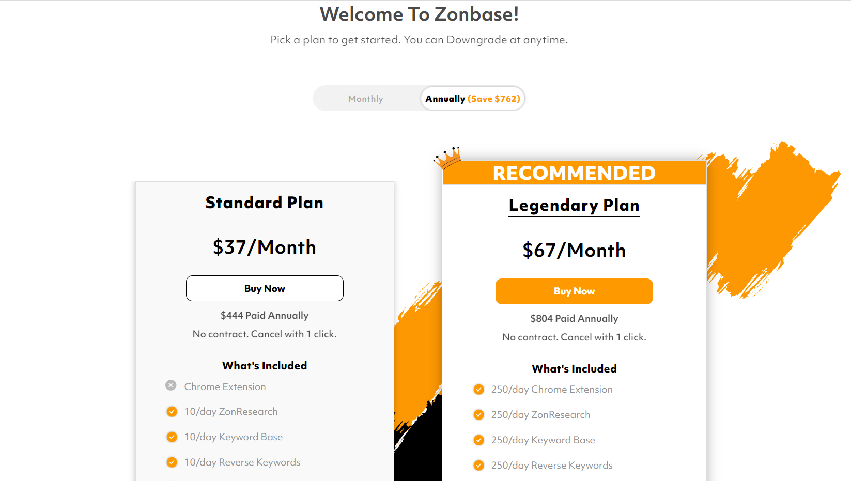

ZonaBase offer two pricing plan for their users

* Standard Plan - $37 per month
* Legendary Plan - $67 per month

### Detail Pricing of ZonBase

Standard Plan offers $37 per month and $444 Annually. You can also get a 7-day money-back guarantee. Features included in the Standard plan are:

* 10/day ZonResearch
* 40/day ZonTracker
* 40/day Sales Estimator
* 10/day Reverse Keywords
* 10/day Keyword Base
* 10/day Hot Products
* 10/day Listify
* 1 store integration Alerts
* 1 Store Integration Profits

Legendary Plan offers $67 per month and $804 Annually. You can also get a 7-day money-back guarantee. Features included in the Legendary plan are:

* 250/day Chrome Extension
* 250/day ZonResearch
* 1000/day ZonTracker
* 1000/day Sales Estimator
* 250/day Keyword Base
* 250/day Reverse Keywords
* 250/day Hot Products
* 250/day Listify
* Integrate 1 store with ZonPPC and spend up to $30k a month
* 3 Store integration Alerts
* 3 Store Integration Profits

## What Can You Do With ZonBase

Given that you now have access to such incredible and potent tools, you must be curious about what else you can do with them and how you can use them to improve the efficiency of the Amazon selling company.

You may locate the ideal keywords for the listings using keyword search. You may view the competitors' keywords with Reverse Keywords. Use it for any product over time to check ranks or display the product's rating on Amazon.

Find appealing items for sale from the more than 20 million products in the Amazon catalog. Finding profitable products is accelerated using the Chrome Extension ZonBase Analysis.

Using the sales estimator, you may view the average monthly sales for each product. The membership includes free private tuition with a specialist operating such a tool.

### Zon Research

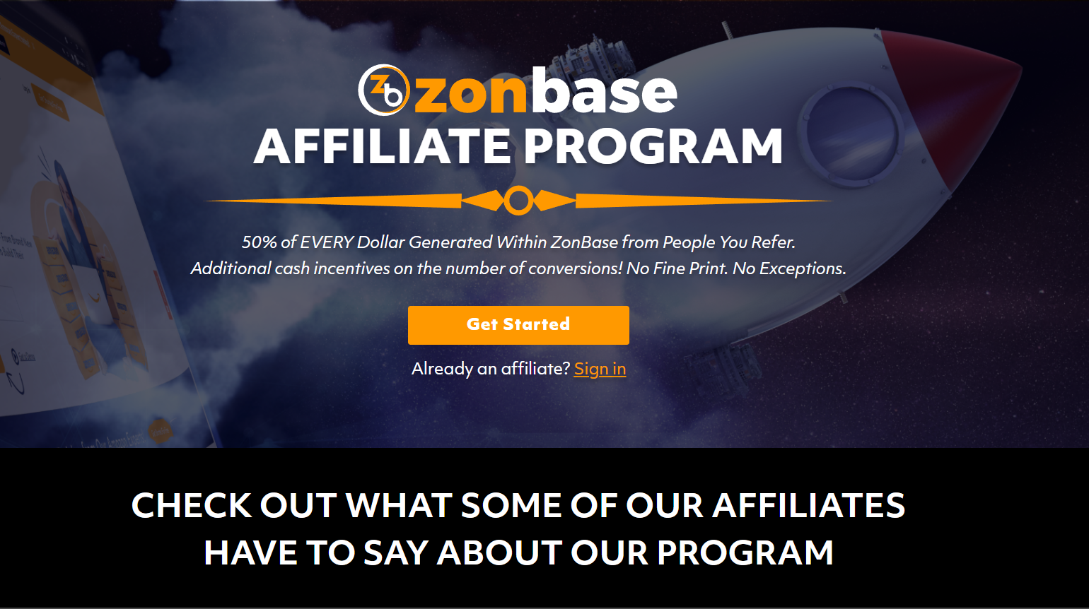

With the help of the ZonBase Research tool, you have full access to Amazon's catalog, which contains more than 400 million items, allowing you to choose lucrative products that match the preferences among the company's top-selling categories. Discovering items with great demand and little competition can help you better compete for customers.

### Chrome Extension

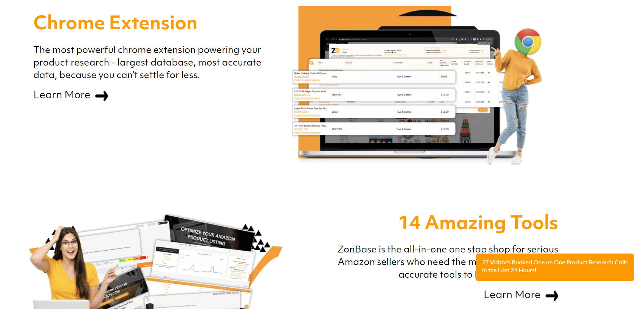

When you surf Amazon.com to hunt for product opportunities, the ZonBase Chrome Extension tool lets you access information about items at a glance and avoid opening several product detail pages. You must conduct an Amazon.com search, install the extension, and click the ZB button. You will access various data via the Chrome Extension, including pricing, BSR, sales history, monthly sales, and more.

### Hot Products

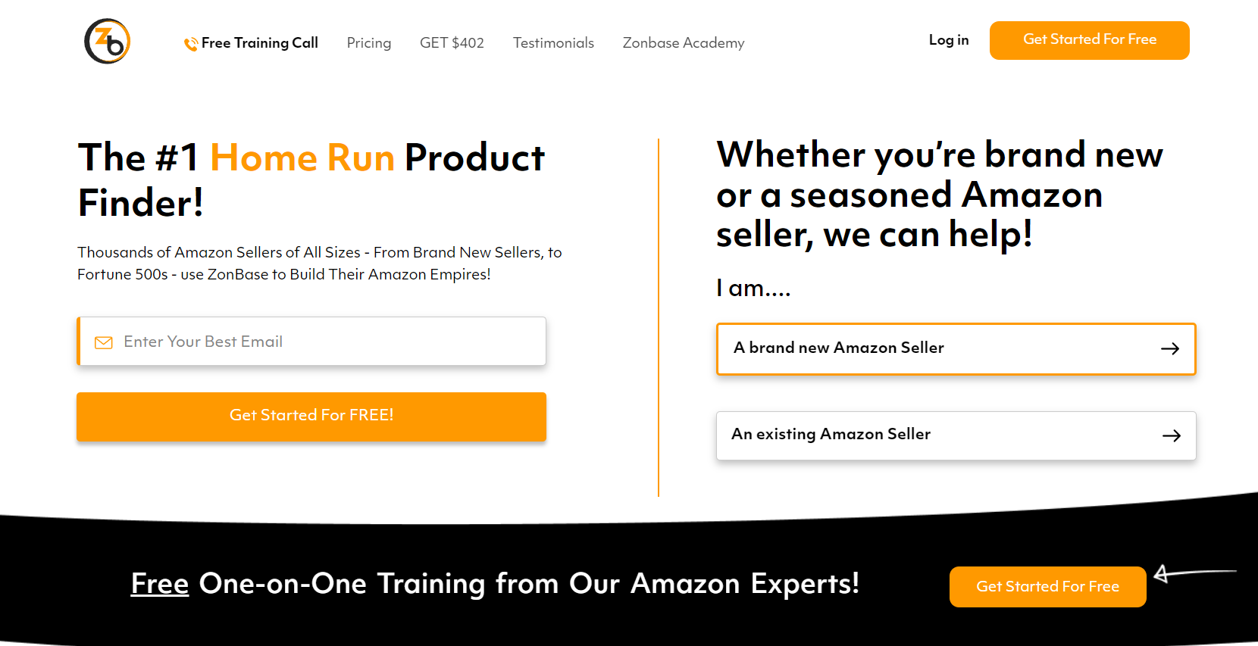

Finding product prospects with untapped potential may be a lot easier with the aid of Hot Products. Unlike Amazon's top seller's list, this tool enables you to find lucrative products from the Amazon Top 100 Most Gifted Products of the Day, focusing on goods with less than 30 reviews and exhibiting rising sales trends.

### Sales Estimator

By obtaining their ASINs, you may use the Sales Estimator tool to look into the monthly sales volume of any potential products you have in mind. This tool aids in evaluating an item's profitability and directs you to how many units you should stockpile.

### Keywords

You may find hundreds of highly effective keywords relevant to the product with our keyword research tool. These keywords might help you optimize the product listing and reach page one. For the items to appear on the first page when consumers click enter during their search on Amazon, it is essential that the listing contain the exact keywords that the target buyers use in their search.

### Reverse ASIN

You may leverage the keywords that the item ranks for on the product listing by using reverse ASIN to discover the product that has ranked organically. By learning which keywords the competition ranks for and applying them in the product listings and PPC campaign bids, you may use this tool to outrank the competitors.

### Zon Tracker

You can monitor what keywords the items are ranking for and keep track of any changes with the help of our rank tracking tool. It also provides information on the terms used by the rivals.

### Listify

To develop the product listing, use this Amazon seller tool to study keywords and evaluate listings from rivals. This helpful tool aids in boosting sales by using pertinent keywords to optimize product listings.

### Photo Enhancer

This one is the most excellent Amazon service for creating stunning, expert-quality explanation visuals from existing product photographs. Clear product photographs are essential for drawing the audience in, creating a positive impression of the items, and encouraging them to buy the products.

## Why should you use ZonBase?

One such platform that gives you almost unlimited options is ZonBase. depends on the type of the business, the niche, and the level of competition present in the industry, even more than what was just discussed.

The platform provides all the tools a developing company needs to be successful in the Amazon market, including the ability to manage PPC, handle search ranking factors, and conduct product and keyword research. The only way to outperform the rivals when selling on Amazon is to base the selections on factual information.

For Amazon merchants, Zonbase is a veritable rich mine of knowledge. Without spending hours browsing internet research sites, you can make informed judgments about what goods and phrases will be most profitable in the future with access to prior sales data.

## FAQs

### Is ZonBase reliable?

Zonbase is a program for Amazon retailers rated as some of the most reliable and affordable software available today. It is an all-in-one piece of software that provides Amazon merchants with all the resources required to rule the online retail giant.

### What are the advantages of the ZonBase tool?

The ZonBase package includes tools for researching products, keywords, and improving listings. You can construct automated campaigns using efficient technologies, so PPC Automation won't be left behind.

There are a few essential tools that every all-encompassing software should include. You can use ZonBase to estimate sales, enhance photos, and earn money, but essential service isn't provided. With ZonBase, sellers can outsource their business operations to a team of professionals.

### Describe Zonbase Pro.

Beginners and seasoned merchants can use Zonbase Pro to navigate Amazon's problematic and cutthroat marketplace.

|  |  |
| --- | --- |
| Features | * Zon Research * Chrome Extension * Keywords * Reverse ASIN * Zon Tracker * Listify * Photo Enhancer |
| Best Suited For | Business |
| Website Languages | English |
| Website URL | [ZonBase](https://www.zonbase.com/) |
| Support email | support@zonbase.com |
| Live Chat | No |
| Company Address | UK |
| Year Founded | 2019 |
| Pricing Range | $0 to $67 |
| Pricing Types | Annual subscription / Monthly subscription |
| Free Plan | No |
| Free Trial | Yes |
| Pricing page link | [Price Page](https://www.zonbase.com/pricing) |

